Talking Points for Pepper and Soap Object Lesson for Forgiveness Sunday.
Adaptable for any age.
Materials Needed: 2 bowls, water, pepper, dishwashing soap
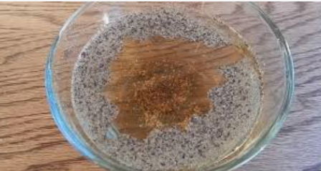
This video shows the step-by-step process. The following bullets are suggested talking and teaching points for today’s theme of Forgiveness:

- The Orthodox Church calls the last Sunday before Lent “Forgiveness Sunday” so we can start Lent on the right track.

- Possible discussions starters: What are some things that can hurt our feelings? What are some things we have forgiven others for? What are some things we have asked for forgiveness for? What does forgiveness mean? Is it hard or easy to forgive? How do you feel when you forgive someone? How do you feel when you are forgiven?

- Fill each bowl with water. Ask “What are some things that can hurt our feelings or someone else’s feelings?” Shake the black pepper into the first bowl each time someone says an answer. As it fills, discuss how our hearts can be filled with hurt when someone does something unkind to us, or when we do something unkind to others. Add dishwashing soap to the bowl and watch the black pepper scatter. When we forgive others, we remove hurt and bitterness from our own hearts. Scatter the second bowl with black pepper, but don’t add dishwashing soap. Add more pepper as you discuss how bitterness from holding things against others can fill our own hearts with pain and sadness.

- Orthodox talking points about forgiveness:

  - “As far as the east is from the west, so far has He removed our sins from us” (Psalm 103:12).

  - Eventually, our resentment eats away at us and we become bitter, angry, and unhappy.

  - In forgiving others, we free up space within ourselves to love, instead of closing ourselves off with resentment.

  - “If you forgive men their trespasses, your Heavenly Father will also forgive you” (vv. 14-15). Sin divides us. Forgiveness breaks through this division and unifies us. To forgive is to put between me and my “enemy” the radiant forgiveness of God. Forgiveness is truly a “breakthrough” of the Kingdom into this sinful and fallen world. (GoArch.org website)

