FASTING
When Jesus wanted to be close to His Father, He prayed and fasted. We can pray and fast to help us be closer to God.
The Church tells us not to eat certain foods during Lent. Please mark whether a food is OK/NOT OKAY to eat during Lent.
This Photo by Unknown Author is licensed under CC BY-SA
Hamburger Fruits Vegetables Pasta
__OKAY __OKAY __OKAY __OKAY
__NOT OKAY __NOT OKAY __NOT OKAY __NOT OKAY

Bread Ice cream Non-meat soup Peanut butter & nuts
__OKAY __OKAY __OKAY __OKAY
__NOT OKAY __NOT OKAY __NOT OKAY __NOT OKAY

Give yourself 1 point for each answer you got correct: __________

**What is one food you will try not to eat during Lent?
______________________________________
Give yourself 1 point if you chose a food not to eat during Lent: ______

TOTAL POINTS ON THIS PAGE = ___________
SUNDAYS BEFORE LENT
Sunday of the Publican & the Pharisee
The Pharisee thanked God that he was so much better than
other men while the Publican begged God to forgive him for being a sinner.
What is our lesson? __________________________________

Sunday of the Prodigal Son
A son asked his father to give him his inheritance early,
and he ended up wasting all the money. When he later
returned home, he asked his father for forgiveness and
the father welcomed him back with open arms.
What is our lesson? __________________________________

Judgment Sunday
We remember that on judgment day God will separate us
into two groups of people: sheep, people who showed love
and compassion during their life, and goats, people who
did not love God during their life.
What things can we do to be one of the “sheep”?
____________________________________________________

Forgiveness Sunday
This is the day before Lent starts. We remember Adam and
Eve getting kicked out of Paradise for disobeying God, and
it reminds us we also need to ask for God’s forgiveness.
Besides God, who else should we ask for forgiveness?
_____________________________________
Give yourself 1 point for each answer you got right: __________
TOTAL POINTS ON THIS PAGE = ___________
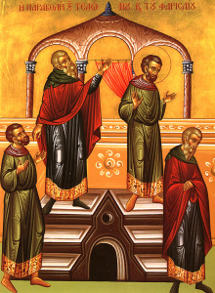

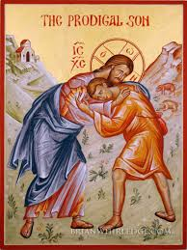

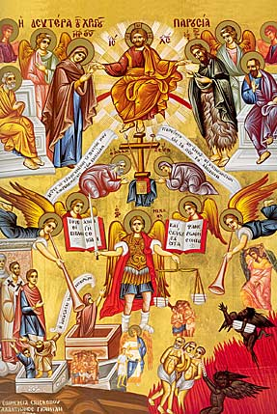

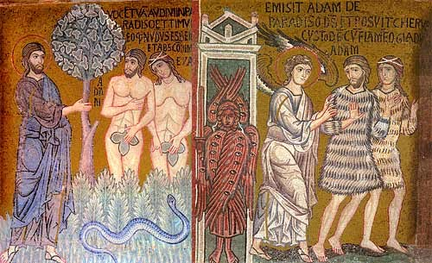

DURING LENT I WILL TRY TO. . .
- Pray more

- Fast

- Give back (do something extra nice for someone)

- Repent (ask God for forgiveness)

- Attend church

#1: SUNDAY OF ORTHODOXY
Give yourself 1 point for each answer you got right: __________
TOTAL POINTS ON THIS PAGE = ___________

#2: ST. GREGORY OF PALAMAS
Give yourself 1 point for each answer you got right: __________
TOTAL POINTS ON THIS PAGE = ___________

#3: VENERATION OF THE HOLY CROSS
Give yourself 1 point for each answer you got right: __________
TOTAL POINTS ON THIS PAGE = ___________

#4: ST. JOHN OF THE LADDER
Give yourself 1 point for each answer you got right: __________
TOTAL POINTS ON THIS PAGE = ___________

#5: ST. MARY OF EGYPT
Give yourself 1 point for each answer you got right: __________
TOTAL POINTS ON THIS PAGE = ___________

TODAY
Are you here at church today? ________
Did you bring an icon? ________
Did you walk in the ceremony? ________

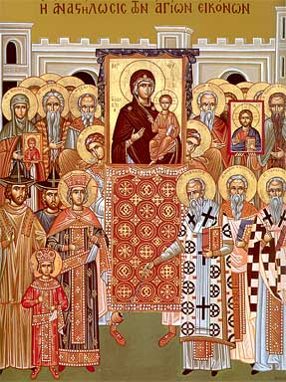

SUNDAY OF ORTHODOXY
A very long time ago, people thought we were worshipping icons and they decided that icons should be removed from the church. In the year 787 it was decided that icons are actually important and should be returned to the church since they remind us of Jesus and the saints. The first procession of icons to celebrate this took place in the year 843.
Do we worship icons? _______________
When you enter a church, what should you do to an icon? __________________
Describe one icon you see in church: _______________________________________

TODAY
Are you here at church today? ________

SUNDAY OF ST. GREGORY OF PALAMAS
St. Gregory taught that it’s the duty of all Christians – not just the priests - to always be in prayer. The one special prayer that Orthodox Christians say all the time is the Jesus Prayer.
Lord Jesus Christ, Son of God, have mercy on me a sinner.
Please write down the Jesus Prayer: _______________________________________
_______________________________________
_______________________________________
_______________________________________

How often did St. Gregory say we should pray?
_______________________________________

5 points for writing down the Jesus Prayer and 1 point for answering the question.
__________

BONUS: GETTING READY FOR PASCHA
2 points for each correct answer

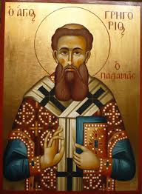
LENTEN GOALS (1 point each)
This week did you …
Remember to pray? ________
Try to fast? ________
Do an extra nice thing?
(Write down what you did & give yourself a point.)
__________________________________________
________
TOTAL POINTS ________

BONUS
This week did you attend a weekday church service? (1 point for each service)
________

LENTEN GOALS (1 point each)
This week did you …
Remember to pray? ________
Try to fast? ________
Do an extra nice thing?
(Write down what you did & give yourself a point.)
__________________________________________
________
TOTAL POINTS ________

BONUS
This week did you attend a weekday church service? (1 point for each service)
________

LENTEN GOALS (1 point each)
This week did you …
Remember to pray? ________
Try to fast? ________
Do an extra nice thing?
(Write down what you did & give yourself a point.)
__________________________________________
________
TOTAL POINTS ________

BONUS
This week did you attend a weekday church service? (1 point for each service)
________

LENTEN GOALS (1 point each)
This week did you …
Remember to pray? ________
Try to fast? ________
Do an extra nice thing?
(Write down what you did & give yourself a point.)
__________________________________________
________
TOTAL POINTS ________

BONUS
This week did you attend a weekday church service? (1 point for each service)
________

SUNDAY OF THE HOLY CROSS
Congratulations! You’re at the halfway point of Great Lent. Are you tired? The Church remembers the Holy Cross right in the middle of Lent to help us make it to the finish line.
Jesus said that being a Christian isn’t always easy and anyone who wants to follow Him “must deny himself, take up his cross, and follow Me.”
Please write down ways you can deny yourself and do something for Jesus instead:
_______________________________________
_______________________________________
_______________________________________
_______________________________________
1 point for each way/max 5 points
BONUS POINT: When you reach the “finish line” of Lent, where will you be?
_______________________________________

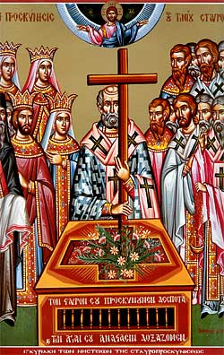

Are you at church today? ________
Did you get a blessed flower? ________

SUNDAY OF ST. JOHN OF THE LADDER
St.John teaches us that we need to lead a God-centered life to get to Heaven. If you look at the icon, angels are helping people climb the ladder while the demons (temptations) are trying to pull them down.
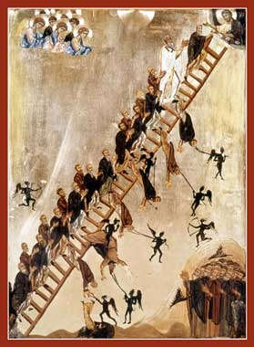
Can you see who’s at the top of the ladder? Who are we trying to reach?
______________________________________
Write down at least one temptation that might try to pull you off the ladder? _____________________________
What’s something we can do to help us stay on the ladder? ________________
What happens if we fall off the ladder? ______________________________

SUNDAY OF ST. MARY OF EGYPT
When St. Mary was a young woman, she lived a very evil life. She was so bad, a force would not allow her to walk into a church. She prayed to God that she would give up her evil life, and then she was able to walk into the church. St. Mary ended up living nearly 50 years alone in the desert where she prayed to God every day, asking Him for forgiveness.
What is our lesson? _________________
_______________________________________

